TEACHER DATA PROFORMA

- Name (in block letters): STEPHEN REMNALAL
- Department: GEOGRAPHY
- (a) Current Designation: ASSISTANT PROFESSOR (ENGAGED)
(b) Date of joining the Service: 01-12-2022
- Sex: MALE
- Category to which belongs: ST
- Address for correspondence: HMARVENG , CHURACHANDPUR.
- Contact Number (M): 7005256591
- E-mail: stephenremnalal@gmail.com
- Academic Qualification (Degree and above):-
Examination | Name of Board/ University | Year of passing | % of Marks obtained | Division/Class/  Grade | Subjects
BA | Manipur University | 2018 | 67.4% | I | GEOGRAPHY
MA | Manipur University | 2020 | 59.6% | II | GEOGRAPHY
NET | UGC | December 2020 to June 2021 Cycle | 52.66 |  | GEOGRAPHY
- Research Degrees: Ph. D. /M. Phil (tick the appropriate one)

Name of the Degree | Title of the Thesis | Date of Award as per University | Name of the University
NIL

- Academic Staff college Orientation/Refresher course attended:-
Name of the course | Name of the Academic Staff College/  Institution | Name of the University | Duration | Sponsoring agency if any
NIL

- Field of specialization under the subjects/ discipline if any: SETTLEMENT GEOGRAPHY

- Published papers in Journals (International Journals, National Journals, Regional Journals):-
Sr. No | Title with page no. | Journal | ISSN/ISBN  No. | Year of Publication | No. of  Co- author | Whether you  are main author
NIL

- Articles/ Chapters published in Books ( International publications, National publications, Regional Publications, State publications):-
Sr No. | Title with page no. | Book, Title, Editor &  publisher | ISSN/ISBN  No. | Whether peer reviewed | No. of Co-  author | Whether you are main  author
NIL

- Full papers in Conference Proceeding ( International, National, State Level Conference:-
Sr. No. | Title with page no. | Details of conference publication | ISSN/ISBN No. | No. of Co-author | Whether you are main author
NIL

- Papers presented in Conference, Seminar, Workshop, Symposia:-
Sr No. | Title of the paper | Title of Seminar/Conference | Organized by | International/National/State/ Regional/College or University
NIL

- PAN No.:-

- Award Received:-
Received awards from state level, national level, international level | Year | Name of the award, fellowship, received from  Government or recognized bodies | Incentives given by the HEI in recognition of the award
NIL

- Minor Research Project awarded:-
Title of the project | Year  of Award | Amount Sanctioned | Duration of the Project | Name of the  Funding Agency | Type  (Government/non Government)
NIL

- For any additional information please provide the details in additional sheets as data required for each item.

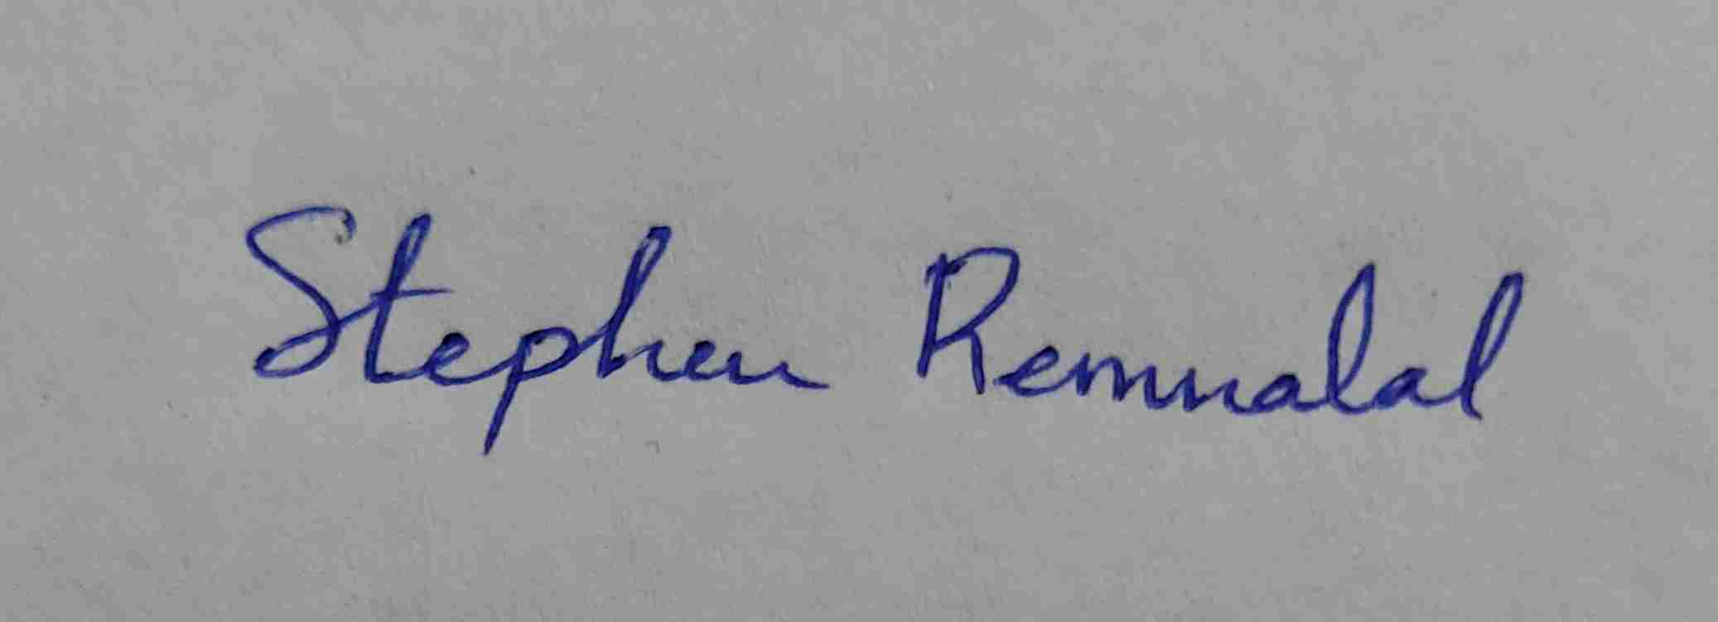

Date: 22/01/2022
Place: CHURACHANDPUR Signature of the teacher

